Design Methods Assignment

In the deep sea lives Herman the

Herman is a rare heteromorphic variant of the typical Hermit Crab. Due to his own rarity he has embarked on a journey around the ocean bed, exploring and collecting any plants and creatures he comes across in a “Catalogue of Intrigues”.

In this game the player would travel the ocean floor as a silent companion for Herman, collecting fish and vegetation.

Logline: Join Herman collecting hundreds of different plants and animals.

Target Audience: 5-13 year olds of both genders.

Character Design

I used a combination of the following images to create Herman the Hermit Crab.

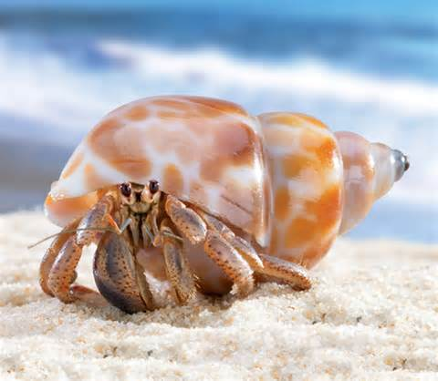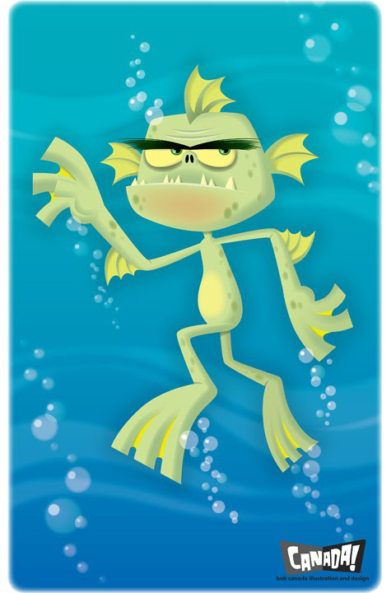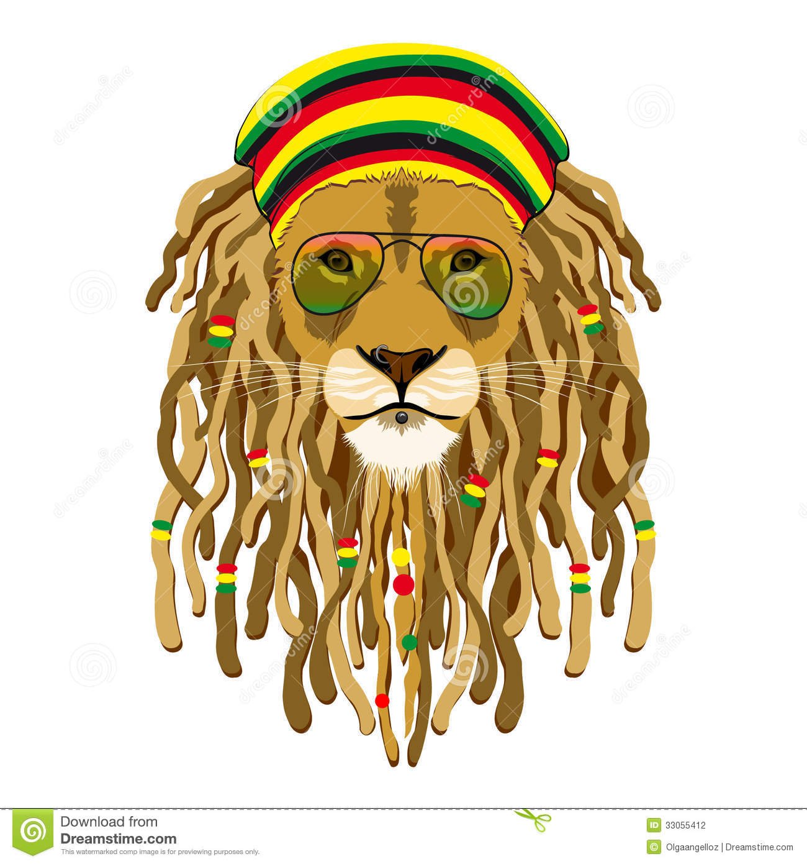

First design – I decided to use a split complimentary colour harmony, using orange, yellow and violet. Orange and yellow for the character and text, whilst using violet for the background. I used the rule of thirds to distribute my focal points, placing the character to be in the centre of the vertical lines on the right, and leaving negative space to the left. I placed the text on the right bottom of the screen to even out the visual weight of the image. Following Gestalt Principles I kept the image and text close together to create association between the information by its proximity to each other. I chose to use a font that was easy to read from a distance, and coloured it yellow to create a contrast against the violet background. I kept the title a brighter, less saturated yellow, and then finally I lowered the strength of the opacity for the Log Line and the character image so that they were not the predominant items on the poster

.

Second design – I kept the basic layout the same (image on the right, text on the left), but this time moved the title text to the centre top of the poster and left the Log Line text at the bottom left. I did this to space out the text, so that it was clear it was not a direct part of the Log Line and therefore avoiding the viewer from visually grouping the two bits of text due to proximity. I also added opacity to the character image, as by lowering it in the previous poster, the poster lost its natural focal point and did not attract attention, as without concentration it didn’t look as if there was a character image at all.

Third Design –I attempted the use of symmetry to create a flow to the image. I used a vertical centre line to align my character and text. I had the character in the top two centre grid squared and placed the Title underneath, with the logline beneath that. While the character was definitely the immediate focal point of the image, the text layout goes against the way in which people naturally read and absorb information, because people read from the top left to the right, then downward in a Z shape. There was also unnecessary grouping of information between the title and log line, and the visual hierarchy implies that the character image is the single priority of the poster.

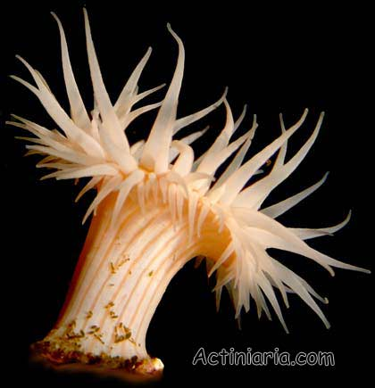

Fourth design – I added an image of one collectable from the game in the form of an sea anemone beneath the title to assist in the balance the colour weight on both sides of the poster. I also used this image because it helps to add to the theme, i.e. that the game is about collecting things underwater. I stayed with the use of asymmetrical grids to group the items of interest, keeping the picture on the right hand side in proximity to the grid line. The title at the top left, and the logline at the bottom left.

Fifth design – Here I used a circle to encompass the character. I used the principals of the symmetrical centre line to balance the image and text. I also tried to offset the orange and blues with a dark red circle that has a lighter red border around the circle to create a higher contrast and draw the eye immediately. I reduced the character size, and erased part of it so that only the head and shoulders fit within the circle. I added the sea anemone to the characters hand to keep the theme of collecting objects underwater consistent between the character image and the text.

Sixth design – I changed colours for the circle and background, as I felt that using a red circle created a conflict within the calm and curious mood that I wanted for the poster, so I attempted an monochromatic colour harmony using blues, whilst keeping the split complimentary colour harmony for the character.

Seventh design – The background colour was changed to a dark blue, to reinforce the underwater theme and to keep the lighter character as the dominant visual image. I also tweaked the placement of the character, lowering it to create a more central position for it between the title and logline text. From here I added a white edging to the character to add more contrast with the background colour. I also added a bevel and emboss effect to the title, to make it appear with more hierarchical importance, and also to create yet more contrast with the background. Finally I added seaweed dangling from the title, and to mildly obscure the sea anemone. I added the sea weed to balance the visual weight on the left and right, and also to add more items of relevant visual interest to the poster. I also removed the circle and returned back to the fifth layout as I felt that this character image and poster layout allowed me to use Gestalt Principles more effectively. It allowed continuation from the characters arm up to the title, and grouping of the “collectable” and character through similarity principles.

Eighth design – Here I began tweaking colours. I was happy with the colours of the character, using a split complimentary colour harmony (blue and orange). I decided to follow the same thought process with the background and text colours, tweaking the dark blue background and orange/yellow text saturation and hue. I also tweaked the opacity values of the title and logline, so the title would be the last thing that a viewer looks at and the logline being the last thing a viewer looks at. This is supported by the way people naturally read in western culture.

Ninth design – I was unhappy with the background colour/texture as whilst the colour was appropriate, I didn’t feel that the background image (or lack thereof) fit with the desired mood. It didn’t make me feel like I was looking at something advertising an aquatic collecting game. So I added a background to give the impression of being underwater – I kept the blues dark to keep the high contrast with the character and text. Also with the aquatic plants, and I felt that their hue and saturation needed to be adjusted to fit better with the monochromatic colour harmony so I raised the saturation, lightened the hue and increased the opacity. Inset is the original image I used for the background.

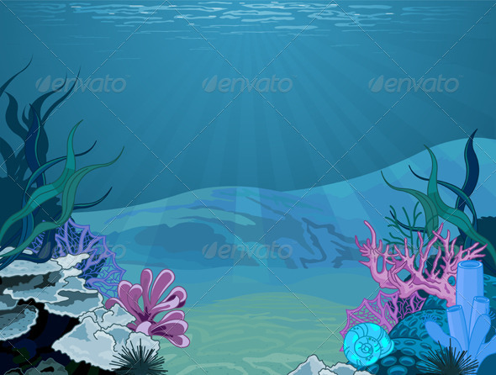

Tenth design – the opacity of the rays of sunlight was too great, the eye was attracted to them immediately as they had greater contrast to the background than was necessary. They are only supposed to be subtle hints to show beams of light, and to direct the players’ eye down from the title. So I lowered the opacity slightly, so they merged better with the background colours. I also changed the colour of the snail on one of the rocks on the right, as it is a “collectable” item (and of relevance to the visual narrative and logline) I felt that the viewer should notice it more.

Eleventh design - in this design I began to consider the typography. I chose MS Sans Serif Regular font, as it is easy to read. It has no embellishments in the way that Serif fonts do which can sometimes be difficult to read, and certainly wouldn’t fit with the theme and style of the poster as it would create a very formal look.

Twelfth design - I changed the font to Dosmilicatorce Regular , as it was a very rounded font and rounded shapes often lend to a harmless and child-like feeling to the subject, which is desirable as Herman is designed to be a side-kick to accompany you on an adventure through the ocean. However the apostrophe in Herman’s was invisible, so I needed to change the font.

Thirteenth design –I decided to change the font to Big Noddle Tilting font, which is a Sans Serif font style. I chose this because it has no embellishments, it appeals to children as it is similar to the fonts used in comic books – however it is less rounded which removes the “childish” feel of it. The font is also easier for people to read from further away, and for older people to read. Whilst older people are not my chosen demographic, they are the people who will be buying the game for a part of my chosen demographic and therefore if they cannot read the type they are unlikely to buy the game.

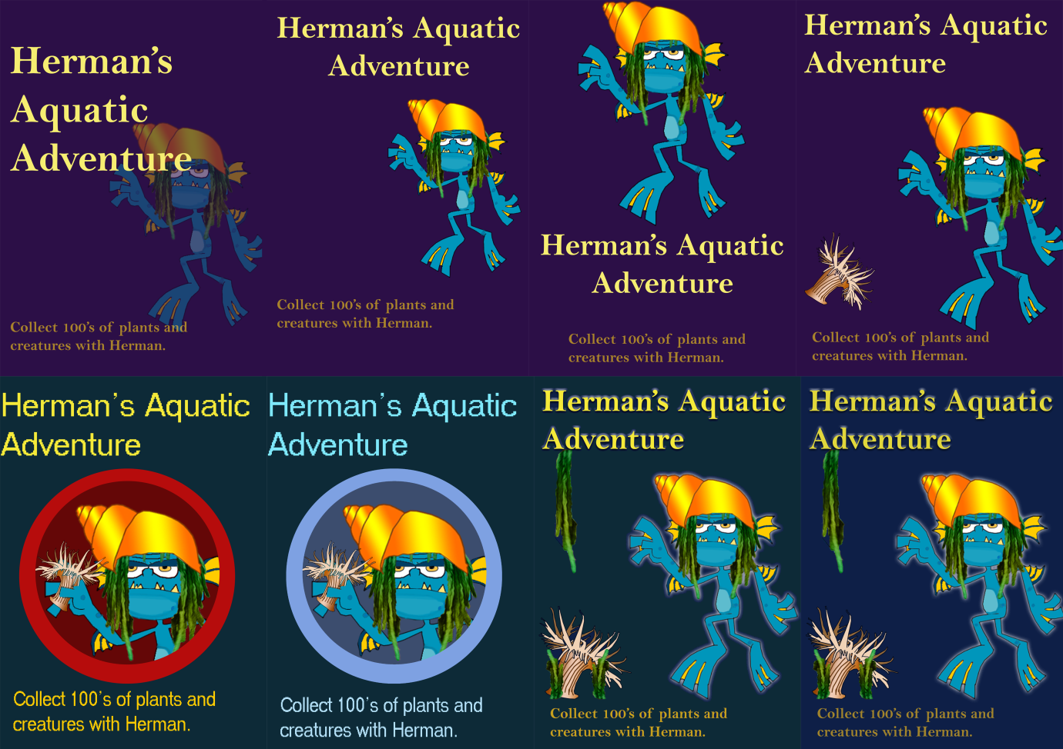



Iterations 1-13, from left to right.

Bibliography

Anonymous(N.D.)*Heteromorphous*[Online] Available at: <http://medical-dictionary.thefreedictionary.com/heteromorphous> [Accessed 16 December 2015].

Steven Bradley. 2015. Design Principles: Compositional Balance, Symmetry and Asymmetry. [ONLINE] Available at: <http://www.smashingmagazine.com/2015/06/design-principles-compositional-balance-symmetry-asymmetry/>. [Accessed 03 December 15].

Creative Bloq. 2015. The designer's guide to Gestalt Theory. [ONLINE] Available at: <http://www.creativebloq.com/graphic-design/gestalt-theory-10134960>. [Accessed 03 December 15].

Visual Communication Design. 2013. The Principle of Balance. [ONLINE] Available at: <https://visscom.wordpress.com/2013/04/page/2/>. [Accessed 03 December 15].

Blender Guru. (2014). *Understanding Composition*. [Online Video]. 15/10/14. Available from: <http://www.blenderguru.com/tutorials/understanding-composition/>. [Accessed: 03 December 2015].

Color Matters. 2015. Basic Color Theory. [ONLINE] Available at: <http://www.colormatters.com/color-and-design/basic-color-theory>. [Accessed 03 December 15].

Blender Guru.(2014) *Understanding Color*. [Online Video]. 27/01/14. Available from: <http://www.blenderguru.com/tutorials/understanding-colors/>. [Accessed 03 December 15].

Aisleone. 2009. 8 Simple Ways to Improve Typography In Your Designs . [ONLINE] Available at: <http://www.aisleone.net/2009/design/8-ways-to-improve-your-typography/>. [Accessed 03 December 15].

Mark Bowley. 2009. A 20 Minute Intro To Typography Basics. [ONLINE] Available at: <http://design.tutsplus.com/articles/a-20-minute-intro-to-typography-basics--psd-3326>. [Accessed 03 December 15].

Dafont. 2009. DaFont. [ONLINE] Available at: <http://www.dafont.com/>. [Accessed 03 December 15].

Paul. (2011) sea-anemone1 [ONLINE]. Available at: https://ben10pol.wordpress.com/ [Accessed 20 November 15].

Anon. (ND) under_sea_001 [ONLINE]. Available at: http://becuo.com/cartoon-underwater-background [Accessed 25 November 15].

Anon.(2011)*HermitCrabpic*[Online] Available at: <http://true-wildlife.blogspot.co.uk/2011/02/hermit-crab.html> [Accessed 20 November 15].

Canada,Bob.(2010)*SaulFinnegan*[Online] Available at: <http://bobcanada92.blogspot.co.uk/2010/06/saul-finnegan.html> [Accessed 20 November 15].

Olgaangelloz(N.D.) *Rasta lion*[Online] Available at: <http://www.dreamstime.com/stock-photography-rasta-lion-vector-illustration-isolated-white-image33055412> [Accessed 20 November 15].